Q#1: Write a C++ program to enter two numbers and find their sum.
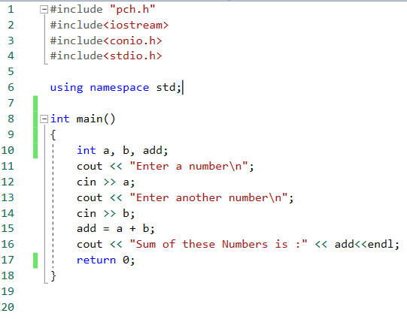

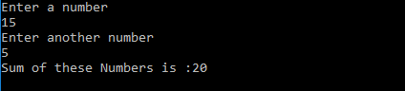

Q#2: Write a C++ program to enter two numbers and perform all arithmetic operations.
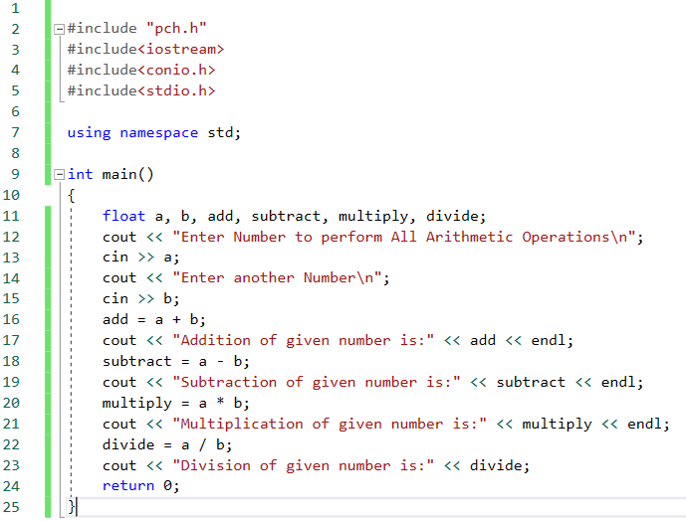

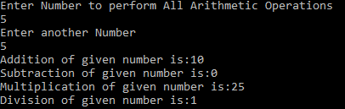

Q#3: Write a C++ program to enter length and breadth of rectangle and find its perimeter.
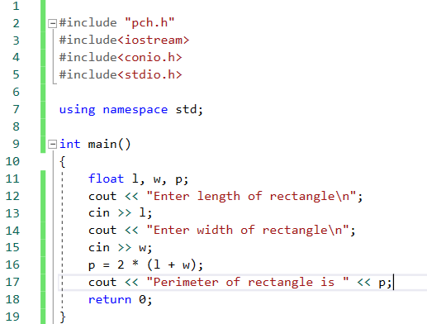

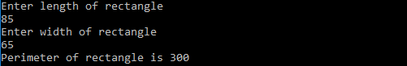

Q#4: Write a C++ program to enter radius of circle and find its diameter,circumference and area.
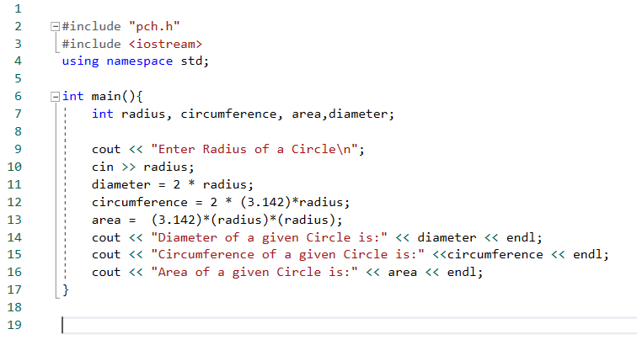
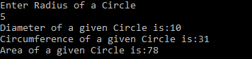

Q#5: Write a C++ program to enter length in centimeter and convert into meter and kilometer.
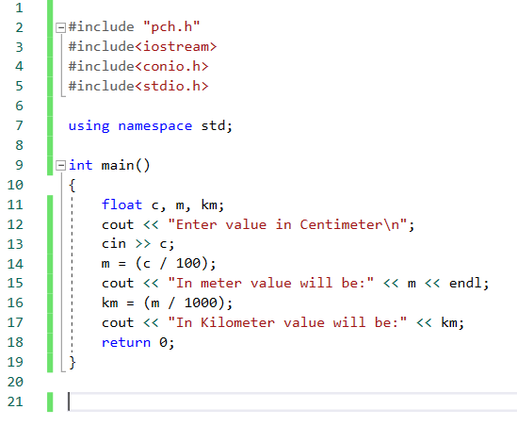
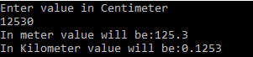

Q#6: Write a C++ program to enter temperature in Celsius and convert into Fahrenheit.
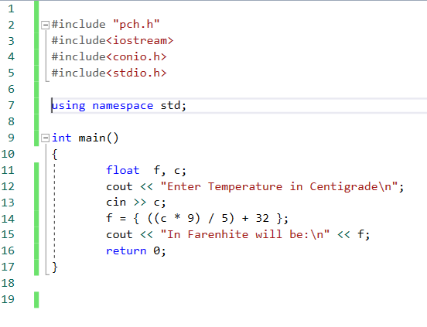
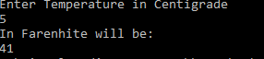

Q#7: Write a C++ program to enter temperature in Fahrenheit and convert into Celsius.
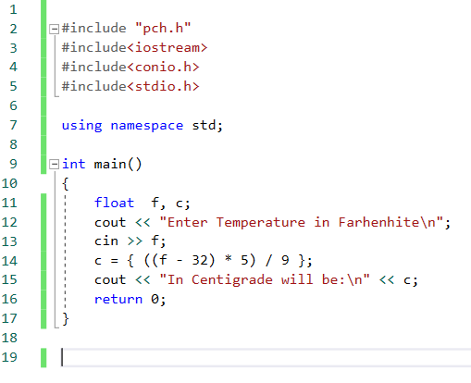

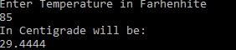

Q#8: Write a C++ program to find power of nay number x^y.
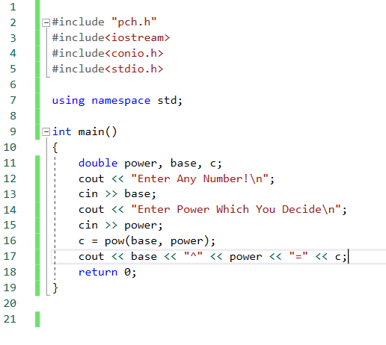

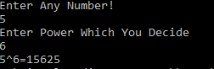

Q#9: Write a C++ program to enter any number to calculate its square root.
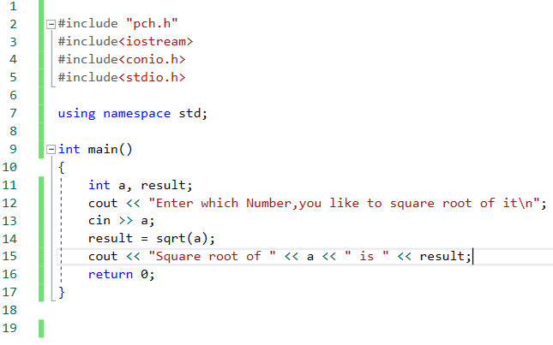

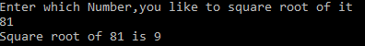

Q#10: Write a C++ program to enter two angles of a triangle and find its third angle.
